
FIMC* MONITORING PROTOCOL
*Fresh water Insect, Molluscs and Crustaceans
Freshwater Ecosystems: Capacity building and access on biodiversity data for improved decision making
A FIMC monitoring protocol has been prepared by the research team of the BID-AF2020-169-USE Project to address the challenges observed during FIMC data mobilization process form different data holders
Why this Protocol?
During BID-AF2020-169-USE project meeting and stakeholders training on FIMC biodiversity data mobilization in 2021; most of the FIMC biodiversity data possessed by stakeholders were not standardized. Stakeholders needed to know more about FIMC biodiversity data standards to be able to share standardized FIMC biodiversity data amongst themselves. The BID-AF2020-169-USE project aimed amongst its outputs to be a FIMC biodiversity data collection protocol that will address this. It involved mobilizing FIMC biodiversity data from different stakeholders, study them and standardize and summarize them into a user friendly protocol that would inspire freshwater ecosystem managers, decision makers and other stakeholders to address FIMC related issues.

What is the BID-AF2020-169-USE Project?
Although the current National Biodiversity Strategy and Action Plan (NBSAP 2015-2020) emphasizes the need for mainstreaming freshwater biodiversity information into sector policies, plans, and programs; the lack of accessible, reliable, and ready to use FIMC biodiversity data hindered its effective implementation by policy and decision-makers, and the realization of NBSAP 2015-2020 targets. This two years (2020-2022) project aimed at mainstreaming FIMC biodiversity data into Government Decision-Making through creation of a useable and accessible FIMC portal, FIMC species distribution maps, FIMC monitoring protocol that can be adopted by policymakers and be integrated into decision-making processes by different stakeholders in different sectors. The project covered the northeastern regions of Tanzania (map below).
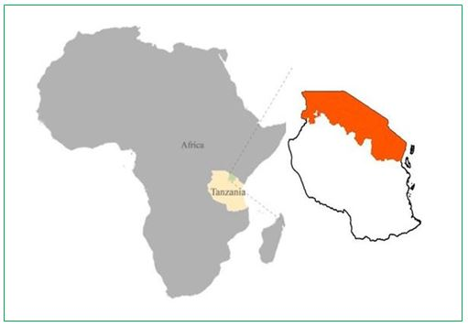
- Over twenty-two thousand FIMC occurrence records were mobilized and included in a FIMC portal. These were obtained from three basins of Pangani, Lake Victoria and Internal drainage basin
- Twenty stakeholders including those who are working with the three basins gathered in Babati district-Tanzania to discuss and comment on the results of the project and priorities for this protocol.
- Twenty stakeholders including those who are working with the three basins gathered in Babati district-Tanzania to review and validate the project’s outputs.
- The protocol will be shared amongst different stakeholder for use
The FIMC monitoring Protocol is one of the output of BID-AF2020-169-USE project and its content was produced based on BID-AF2020-169-USE project activities

African Freshwater Ecosystem Managers and decision makers: It is your FIMC monitoring protocol!
This protocol intends to primarily reach the freshwater ecosystems managers (Basin authorities) and administrators but also decision makers who are involving in day to day decision making on freshwater ecosystems, defuse freshwater related conflicts, be in dialogue with any stakeholders and promote the protection of freshwater ecosystems.
The main objectives of the protocol
- To build capacity amongst freshwater ecosystem stakeholders on FIMC data collection in standardized format
- To increase awareness, access and knowledge of biodiversity data amongst relevant stakeholders and decision makers
- To serve as a support and background document for decision makers on freshwater use and beyond

Content
I am a policy maker, decision maker, politician, authority, freshwater ecosystem manager

Cap. X: Chapter that contains a link of published FIMC species
Cap Y: chapters that describe FIMC portal and FIMC data categorization
Cap Z: chapter that describe standard form for FIMC biodiversity data collection
Cap A: chapter that describes occurrence, distribution and abundance of FIMC biodiversity

I would like to:
- Refresh my understanding in FIMC species
- Better understand of FIMC species of conservation importance
- Better understand of FIMC species of health importance
- Better understand of FIMC species of food importance
- Have an idea about existing rapid tools for FIMC biodiversity assessment
- Translate FIMC biodiversity data knowledge into concrete actions

